**How to activate or deactivate a Module**

1. Login as **super admin (admin/test).**

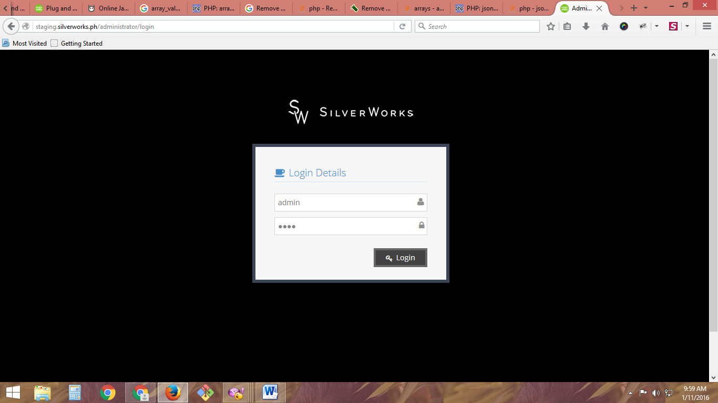

2. Click **Settings**.

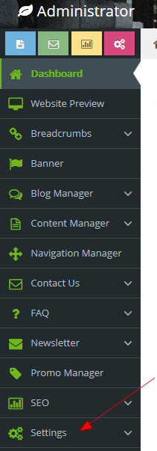

3. Click **Modules**

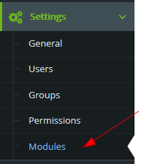

4. Select a module to be updated by clicking view or edit button.

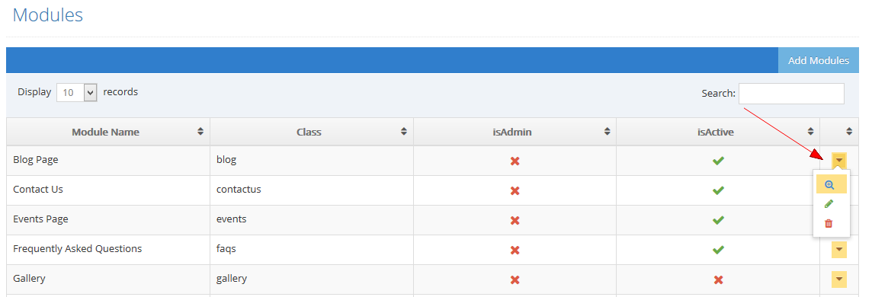

* **isAdmin** – is the status if the module is for admin/backend or frontend use (inactive means the module is for frontend us).

* **isActive** – is the status if the module is active and ready for use.

5. Click is Admin to check if the module is admin use and leave it uncheck if not for admin. Click isActive to check if the module should be used by the system.

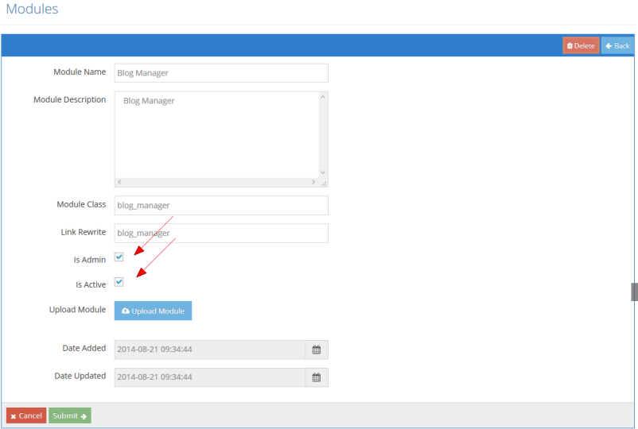

6. Click the submit button.

